Project Design Phase-II
Technology Stack (Architecture & Stack)

Date | 31 January 3035
Team ID
Project Name
Maximum Marks | 4 Marks

Technical Architecture:
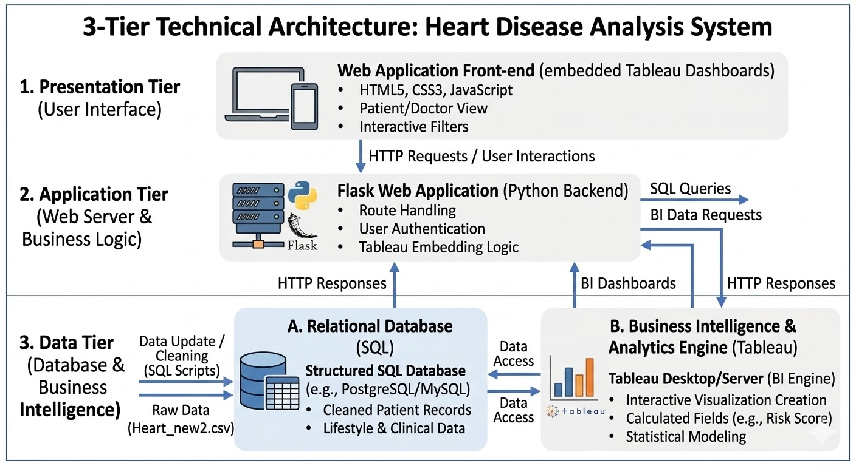

Table-1 : Components & Technologies:
 | Component | Description | Technology
 | User Interface | Web UI where users and doctors view the interactive heart disease dashboards. | HTML, CSS, JavaScript (Embedded Tableau Views)
 | Application Logic-1 | Web Server Routing: Manages web pages, handles user requests, and serves the dashboard. | Python (Flask Framework)
 | Application Logic-2 | Business Intelligence Engine: Processes data visually, computes correlations (BMI, Age, Smoking), and generates interactive plots. | Tableau Public
 | Application Logic-3 | Data Engineering: Scripts to clean missing values and transform the raw clinical data. | SQL Queries
 | Database | Stores the structured and cleaned patient records for fast querying. | MySQL
 | Cloud Database | Hosting the BI extracts for remote access. | Tableau Public
 | File Storage | Storing the initial raw dataset (Heart_new2.csv) before it is imported into the database. | Local Filesystem (.csv format)
 | External API-1 | Embedding the visualizations into the custom web application. | Tableau Embed API
 | External API-2 | NA | NA
 | Machine Learning Model | NA | NA
 | Infrastructure (Server / Cloud) | NA | NA

Table-2: Application Characteristics:
S.No | Characteristics | Description | Technology
 | Open-Source Frameworks | The core backend routing and data transformation use open-source Python libraries. | Flask (Web Framework), Pandas (Data Processing)
 | Security Implementations | Protecting the database from malicious queries and securing the web application sessions. | SQL Injection Prevention (Parameterized queries), Flask Secret Key (Session Security).
 | Scalable Architecture | The system uses a modular 3-Tier Architecture (UI frontend, Flask backend logic, SQL/Tableau data tier) allowing each part to scale independently. | Flask (Backend), SQL (Data Tier), Tableau (Analytics Tier)
 | Availability | The web application is hosted on a continuous server environment to ensure doctors can always access patient risk dashboards. | WSGI Web Server (e.g., Gunicorn running Flask)
 | Performance | Dashboards load instantly because Tableau pre-aggregates the data instead of querying the database for every single click. | Tableau Data Extracts (.hyper files) for high-speed rendering

